ALUMNEX CONNECT
Complete Agile, Jira Project Management & Documentation Guide
Project Key: KAN | Current Board: KAN board | Current date: 06 October 2026
Prepared from the verified connected Jira/Confluence project state and the project-management structure created for Alumnex Connect.

Contents
1. Executive Summary
2. Project and Agile Context
3. Jira Project Structure
4. Board Workflow and Work Item Lifecycle
5. Epics, Stories, Subtasks and Bugs
6. Release / Phase Management
7. Dependencies and Risk Visibility
8. Defect Management
9. Story Points and Estimation
10. Scrum Governance and Ceremonies
11. Definition of Ready and Definition of Done
12. Metrics and Continuous Improvement
13. Confluence Documentation Layer
14. Mapping to Agile Methodologies
15. How Each Artifact Applies to Your Project
16. Screenshot Evidence Plan
17. Important Constraints and Academic Reporting Rules
18. Recommended Operating Model for Future Iterations
19. Appendix A — Complete Epic Register
20. Appendix B — Story Register
21. Appendix C — Subtask Register
22. Appendix D — Bug Register

1. Executive Summary
Alumnex Connect is currently represented in Jira as a team-managed software project with key KAN. The project contains 10 Epics, 53 Stories, 20 Subtasks and 5 Bugs, for a total of 88 Jira issues. The connected project also contains five Jira Versions used as delivery phases and a Confluence Agile/Scrum playbook that explains how the work should be managed.
The important Agile distinction is that the project is documented in a Scrum-oriented vocabulary (product backlog, Sprint Planning, Daily Scrum, Sprint Review, Retrospective, Definition of Done), while the currently verified Jira board is a simple/team-managed board and does not support native Jira Scrum Sprints. Therefore, this report separates what is implemented in Jira from what is documented as the intended Agile operating model.
The documentation can be used in a project report, viva, review presentation or internal handover. It explains what each Jira artifact represents, how it participates in an Agile lifecycle, how it maps to Scrum, Kanban, XP and Lean concepts, and which screenshots should be captured from the live workspace for evidence.
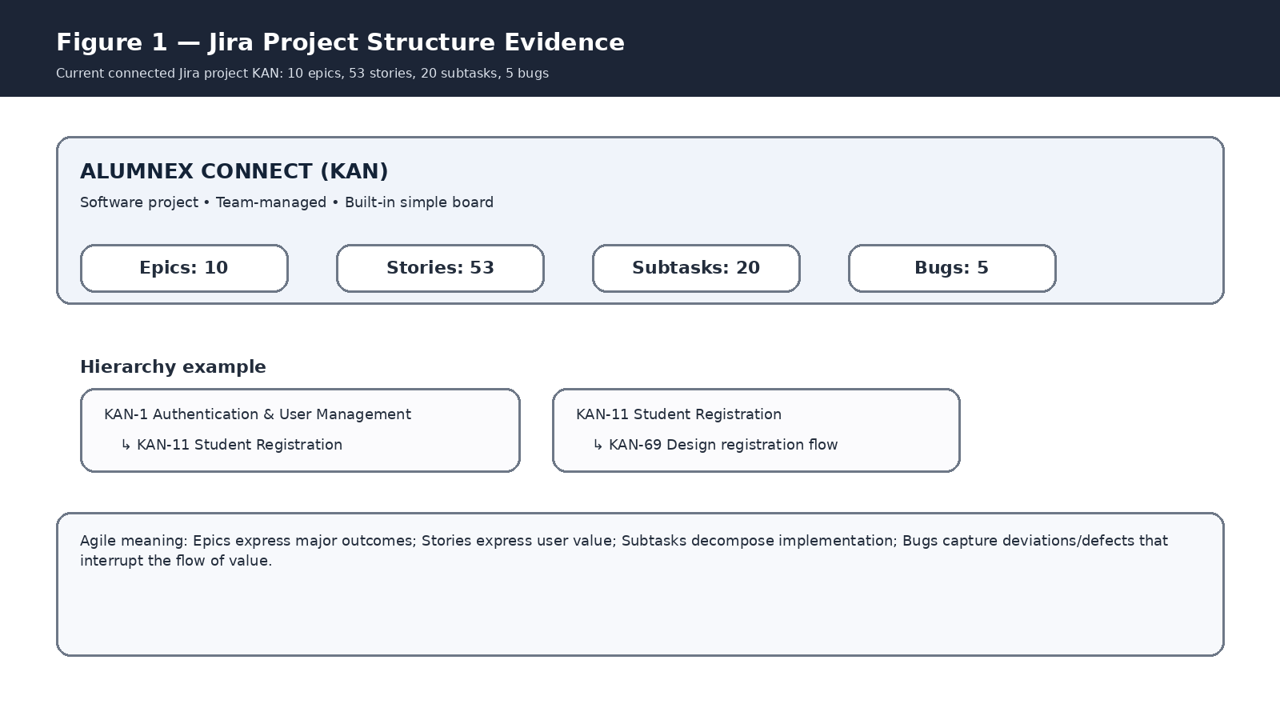
Figure 1. Connector-derived evidence visualization of the current KAN hierarchy. This is not a literal pixel screenshot of the Jira UI.

2. Project and Agile Context

2.1 Product context
Alumnex Connect is an integrated alumni-student ecosystem that combines authentication, mentorship, developer intelligence (DevPulse), career and job functions, AI career support, real-time communication, community features, mobile access, and platform reliability/security. The Jira backlog was reconstructed around these product areas so that the project can be managed as a coherent Agile product rather than as an unstructured collection of features.

2.2 Agile interpretation
Agile is the umbrella approach: deliver value incrementally, obtain feedback frequently, keep work visible, and adapt the plan as learning occurs. Scrum, Kanban, XP and Lean are different ways of operationalising those principles. For Alumnex Connect, the strongest current implementation is a Jira workflow + release-phase structure with Scrum governance documentation layered over it.

2.3 What is currently true in Jira
- KAN is a team-managed project and its built-in board is named KAN board.
- The board workflow contains Idea, To Do, In Progress, In Review and Done.
- Five Jira Versions are used as Phase 1 through Phase 5 release groupings.
- Eight issue links of type Blocks were created to expose important dependencies.
- Five defects are tracked as Jira Bugs and linked to related work where applicable.
- The 53 Stories contain suggested estimates in their descriptions; the project does not expose a Story Points field in its issue-type metadata, so the estimates are not falsely represented as native Story Points.
- The Confluence playbook documents Scrum ceremonies, backlog refinement, quality gates, metrics, risk/dependency management and release management.

3. Jira Project Structure

3.1 Epic layer
Epics are the portfolio-level product capability containers. Each Epic groups a coherent functional area and gives the team a higher-level view of the product roadmap. In Agile terms, an Epic is useful when the value is too large to deliver as one Story and must be decomposed into smaller increments.
Key | Epic | Agile purpose
KAN-1 | Authentication & User Management | Identity, access and profile foundation
KAN-2 | Alumni–Student Mentorship | Mentor discovery and mentorship workflow
KAN-3 | Developer Intelligence — DevPulse | Developer data, activity and consistency
KAN-4 | Career & Job Management | Jobs, applications and ATS
KAN-5 | AI Career Assistant | AI-driven career support
KAN-6 | Real-Time Communication | Chat, presence and notifications
KAN-7 | Community & Events | Forum, events and networking
KAN-8 | Mobile Application | Android/mobile delivery experience
KAN-9 | Security, Reliability & DevOps | Security, testing, failover, CI/CD, monitoring
KAN-10 | Scrum & Project Governance | Backlog, ceremonies, quality gates and metrics

3.2 Story layer
Stories are the primary user-value units. The standard Alumnex Connect Story structure is: user goal + acceptance criteria + suggested estimate. This is directly aligned to Agile product backlog practice because a Story is written in terms of who needs something, what they need, and why the capability matters.
Examples include KAN-11 Student Registration, KAN-26 Activity Hub, KAN-32 ATS Resume Analysis, KAN-33 AI Career Mentor, KAN-45 Android Mobile Wrapper and KAN-50 Security Hardening.

3.3 Subtask layer
Subtasks decompose implementation within a Story. They are particularly useful when a Story contains several technical activities that should remain traceable to the same user outcome.
Range | Count | Examples
KAN-69–KAN-74 | 6 | Registration/login implementation and tests
KAN-75–KAN-77 | 3 | Mentor discovery/request implementation and tests
KAN-78–KAN-80 | 3 | GitHub, activity aggregation, streak calculation
KAN-81–KAN-82 | 2 | Resume extraction and ATS scoring
KAN-83–KAN-85 | 3 | AI chat, socket messaging, notification deduplication
KAN-86–KAN-88 | 3 | Android wrapper, FCM registration, security review

3.4 Bug layer
Bugs represent defects or deviations that require engineering work. Their presence is important in Agile because quality work is part of the product backlog rather than an activity hidden outside the iteration process.

4. Board Workflow and Work Item Lifecycle
The verified KAN board workflow has five columns: Idea, To Do, In Progress, In Review and Done. It is therefore suitable for visualising flow, prioritisation and review. The workflow can support Agile work even without native Scrum sprints.
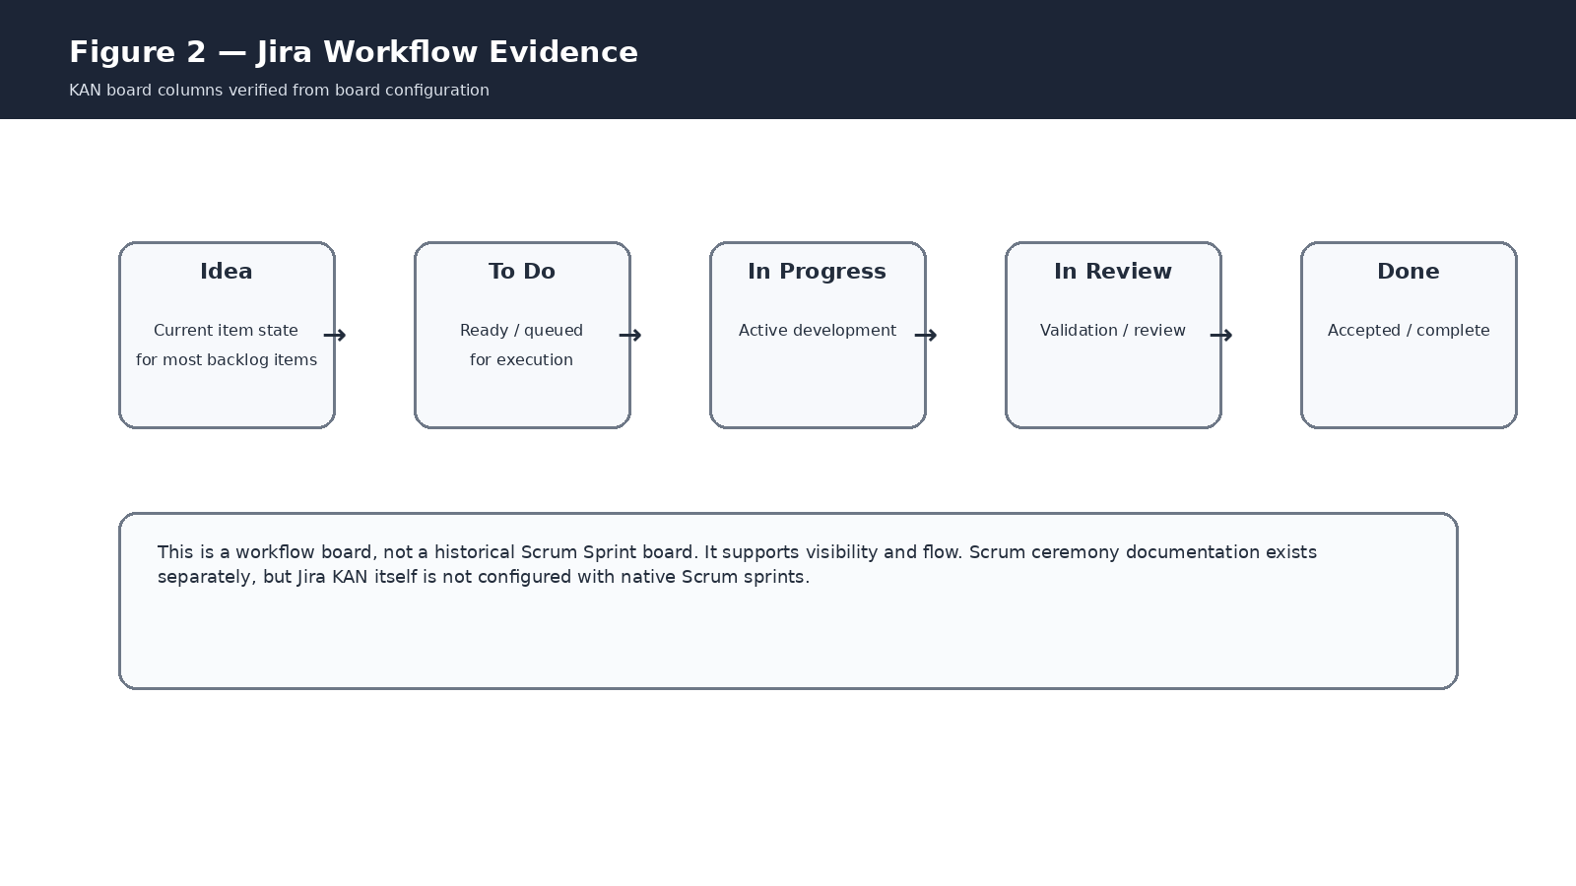
Figure 2. Verified board workflow translated into an Agile lifecycle view.

4.1 Recommended lifecycle
1. Idea — capture a potential capability, issue or improvement before commitment.
2. To Do — work is refined enough to be selected for execution.
3. In Progress — implementation is actively underway.
4. In Review — the work is undergoing testing, review or acceptance checks.
5. Done — acceptance criteria and the Definition of Done are satisfied.
For academic documentation, describe this as the project work-flow lifecycle rather than calling every movement a Sprint state. A Sprint is a time-boxed Scrum event/context; the board columns are workflow states.

5. Epics, Stories, Subtasks and Bugs

5.1 How the hierarchy supports Agile decomposition
Level | Question answered | Example
Epic | What major outcome area are we building? | KAN-3 DevPulse
Story | What user value should be delivered? | KAN-26 Activity Hub
Subtask | What implementation work is required? | KAN-79 Activity aggregation
Bug | What defect is preventing or degrading expected value? | KAN-64 Streak synchronization loss

5.2 Acceptance criteria
Acceptance criteria act as observable conditions for Story completion. They reduce ambiguity during implementation and provide a basis for testing and review. In Scrum, they help a Product Owner and Developers share a common interpretation of what the increment must achieve.

6. Release / Phase Management
Five Jira Versions provide a release-planning layer across the backlog. They are useful because a product can be incrementally organised into coherent capability phases even when a project does not have native Jira Sprints.
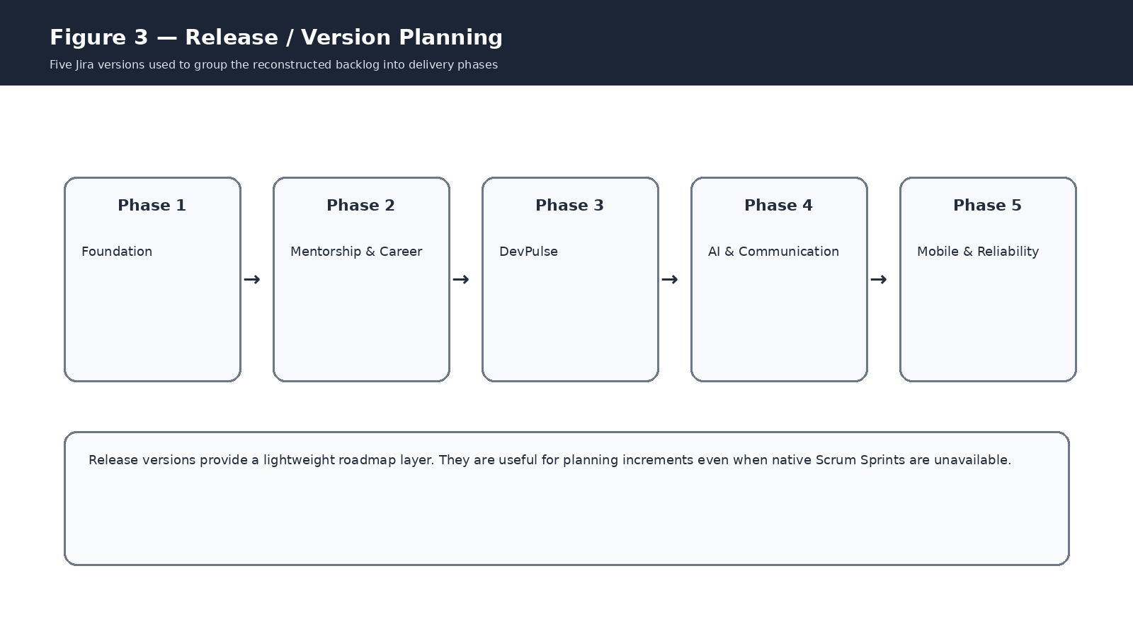
Figure 3. Release/Version phase model currently configured in Jira.
Version | Purpose | Primary areas
Phase 1 — Foundation | Authentication, profiles, RBAC and governance | Auth + Governance
Phase 2 — Mentorship & Career | Mentorship, jobs, applications and ATS | Mentorship + Career
Phase 3 — DevPulse | Developer integrations, activity hub and streaks | DevPulse
Phase 4 — AI & Communication | AI, chat and notifications | AI + Communication
Phase 5 — Mobile & Reliability | Mobile, security, failover, testing and monitoring | Mobile + Platform reliability
Agile application: release phases are a roadmap construct. A future Scrum implementation would place selected Stories from these phases into time-boxed Sprints while keeping the Version as the larger release target.

7. Dependencies and Risk Visibility
Eight Blocks links are currently recorded. These links make cross-feature dependencies visible, so the team can discuss sequencing and blockers during refinement and planning.
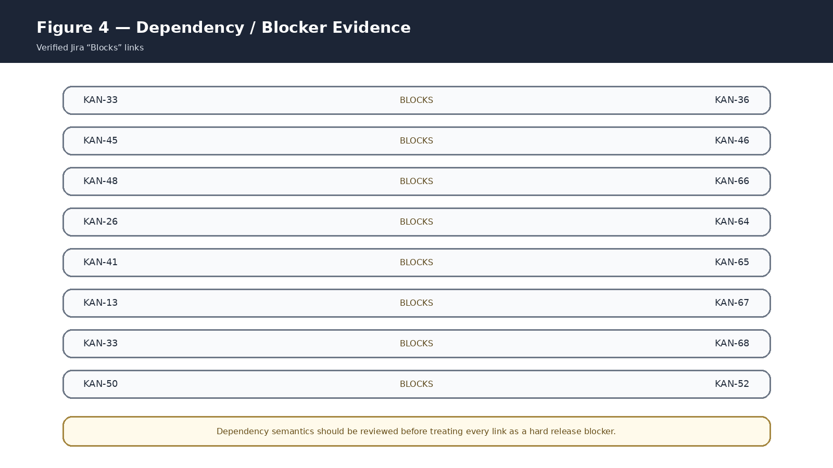
Figure 4. Current Jira Blocks links, rendered as an evidence visualization.
Source | Blocks | Why it matters
KAN-33 | KAN-36 | AI Career Mentor linked to AI provider failover
KAN-45 | KAN-46 | Mobile wrapper depends on reliable mobile authentication
KAN-48 | KAN-66 | Mobile notifications linked to the observed FCM defect
KAN-26 | KAN-64 | Activity Hub linked to observed streak synchronization defect
KAN-41 | KAN-65 | Real-time notifications linked to duplicate-delivery defect
KAN-13 | KAN-67 | OAuth authentication linked to redirect URI defect
KAN-33 | KAN-68 | AI Career Mentor linked to calendar scope defect
KAN-50 | KAN-52 | Security hardening linked to automated testing
Important governance note: some of these relationships may behave more like “related work” than strict release blockers. They should be validated by the team before being used as hard sequencing rules.

8. Defect Management
The defect register contains five observed/reported problems. Their descriptions include acceptance/fix criteria and a tracking note stating that the current implementation should be verified before closure. This is good Agile defect discipline because the issue states what must be proven, not merely that something “seems broken”.
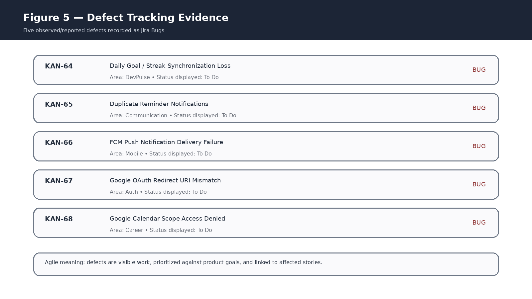
Figure 5. Current defect register evidence visualization.
Bug | Area | Fix/acceptance intent
KAN-64 | DevPulse | Persist/synchronize goal completion, reconcile missed events, idempotent sync, expose last-sync timestamp
KAN-65 | Communication | Deduplicate by event/notification ID, coordinate channels, add delivery logging
KAN-66 | Mobile | Validate FCM token lifecycle, credentials, retries and safe delivery logging
KAN-67 | Auth | Align authorized redirect URIs with active backend callback configuration
KAN-68 | Career / Calendar | Review scopes, consent configuration, graceful denial handling and documentation

9. Story Points and Estimation
All 53 Stories contain a “Suggested estimate” value in their Jira description. The distribution is 29 Stories × 5 points, 15 Stories × 3 points, 8 Stories × 8 points and 1 Story × 2 points, for a total of 256 suggested points.
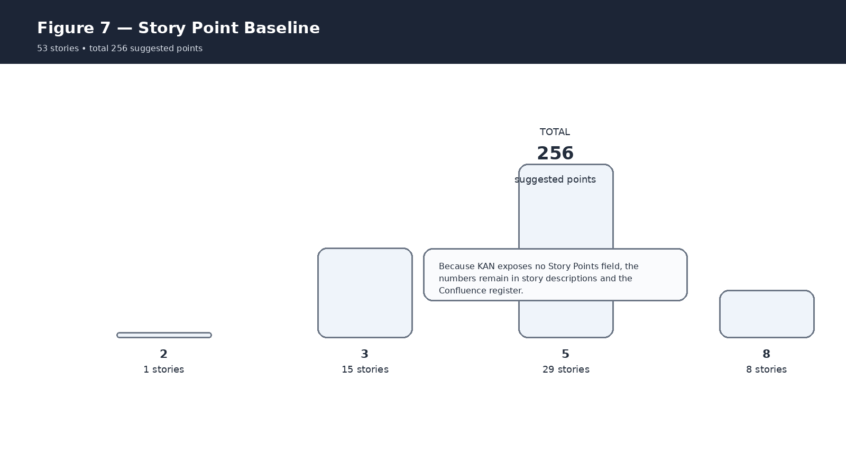
Figure 7. Story-point baseline derived from the 53 existing Story descriptions.
These estimates are useful for relative sizing and future planning. They should not be described as historical velocity because no native Jira Scrum Sprint history exists on the current board. Also, the KAN project metadata exposes no Story Points field, so the documentation preserves the values instead of inventing a field that Jira does not provide.

9.1 How estimation applies to Agile
- Scrum: use points to understand expected workload for a Sprint, then compare planned versus completed work after several Sprints to identify a stable velocity range.
- Kanban: points are optional; throughput, cycle time and work-item age are more central. Points can still support relative sizing.
- XP: estimates help planning and coordination, while technical quality is strengthened through automated testing, refactoring and continuous integration.
- Lean: estimation should remain lightweight and should not become a bureaucracy; the objective is better decisions about flow and value.

10. Scrum Governance and Ceremonies
The governance Epic KAN-10 and Stories KAN-55 through KAN-63 document the intended Scrum management practices. They should be presented as the project’s Agile governance model rather than as proof that historical Jira Sprints were executed.
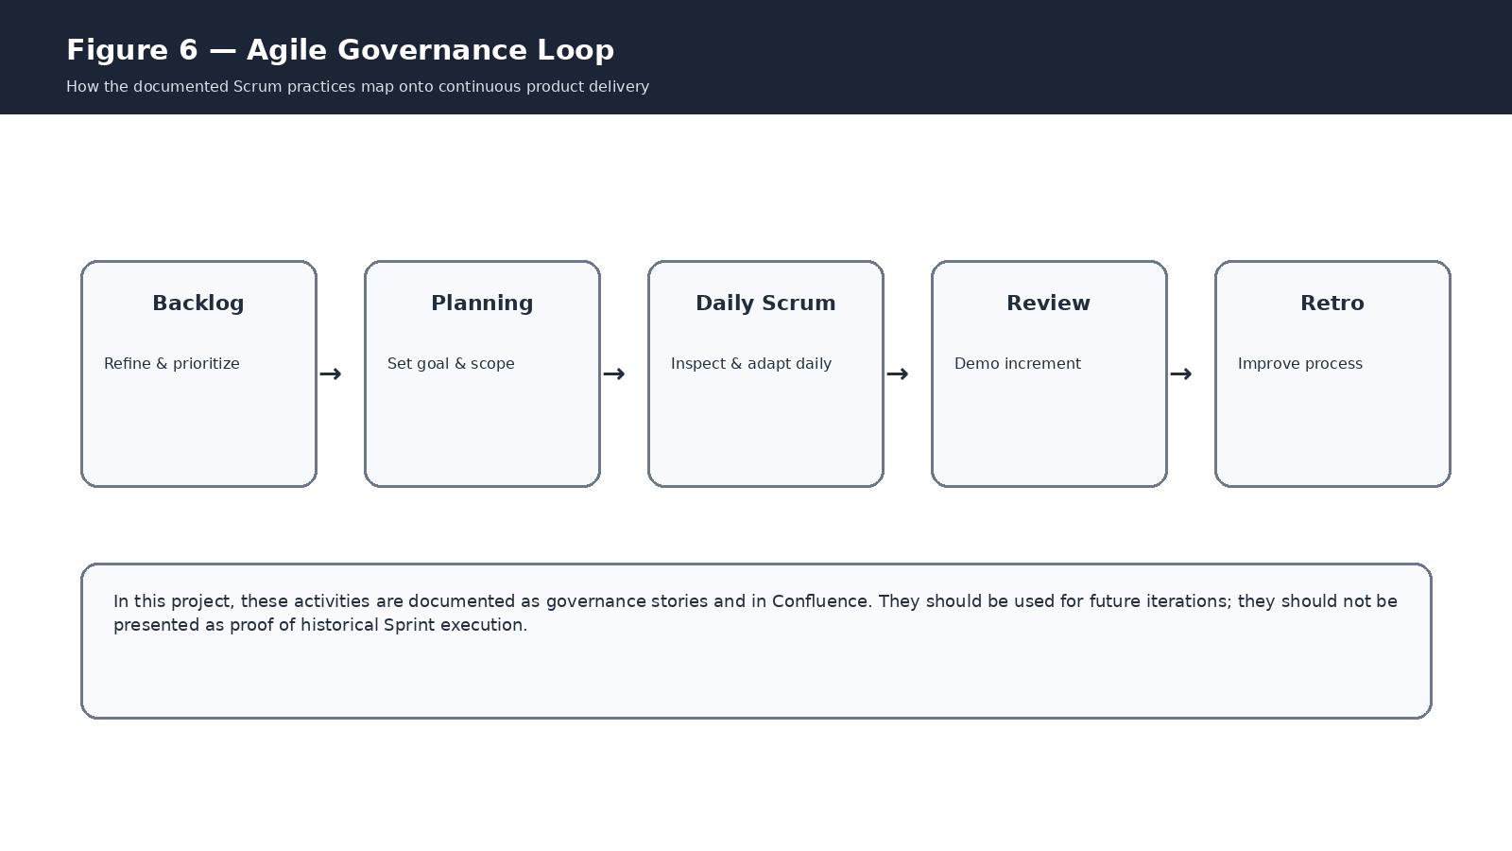
Figure 6. Scrum governance loop documented for future iterations.
Jira Story | Ceremony / practice | Application
KAN-55 | Backlog & Refinement | Keep outcomes, priorities and acceptance criteria current
KAN-56 | Sprint Planning | Define Sprint Goal, scope, capacity and ownership
KAN-57 | Daily Scrum | Inspect progress and surface blockers
KAN-58 | Sprint Review | Demonstrate increment and capture stakeholder feedback
KAN-59 | Retrospective | Identify actionable process improvements
KAN-60 | DoR / DoD | Define readiness and quality gates
KAN-61 | Risk / Dependency / Decision tracking | Make blockers and important choices traceable
KAN-62 | Release / Version tracking | Connect backlog scope to release phases
KAN-63 | Agile metrics | Use flow and delivery data for improvement

11. Definition of Ready and Definition of Done

11.1 Definition of Ready (DoR)
A Story should normally be considered Ready when the desired user outcome is clear, the acceptance criteria are testable, important dependencies are understood, the work is small enough for the intended iteration, and the team can explain what evidence will demonstrate success.

11.2 Definition of Done (DoD)
For Alumnex Connect, a defensible DoD is: implementation completed; acceptance criteria satisfied; relevant automated/manual testing completed; review completed where applicable; security/privacy implications checked where applicable; deployment/build considerations handled; and documentation updated where needed.
This quality gate links directly to Agile’s principle of delivering a usable increment rather than merely completing coding tasks.

12. Metrics and Continuous Improvement
Agile metrics should be used to improve the system of work, not to rank individual people. Recommended measures for Alumnex Connect are: throughput, cycle time, work-in-progress, defect trends, release readiness, Sprint completion (once native Sprints exist), and velocity as a planning signal after enough Sprint history accumulates.

12.1 Metric interpretation
Metric | Meaning | Agile use
Velocity | Story points completed per Sprint | Capacity planning after Sprint history exists
Throughput | Number of items completed in a period | Flow visibility and trend analysis
Cycle time | Time from start to Done | Detect bottlenecks
WIP | Items currently being worked | Control multitasking and congestion
Defect trend | Open/new/closed defects over time | Quality feedback
Release readiness | Scope and risk against a target release | Go/no-go discussion

13. Confluence Documentation Layer
Confluence is the narrative and knowledge layer around Jira. The project has a dedicated Agile/Scrum playbook page containing the operating model, ceremonies, backlog refinement, quality gates, metrics, defects, risks, dependencies and release management.
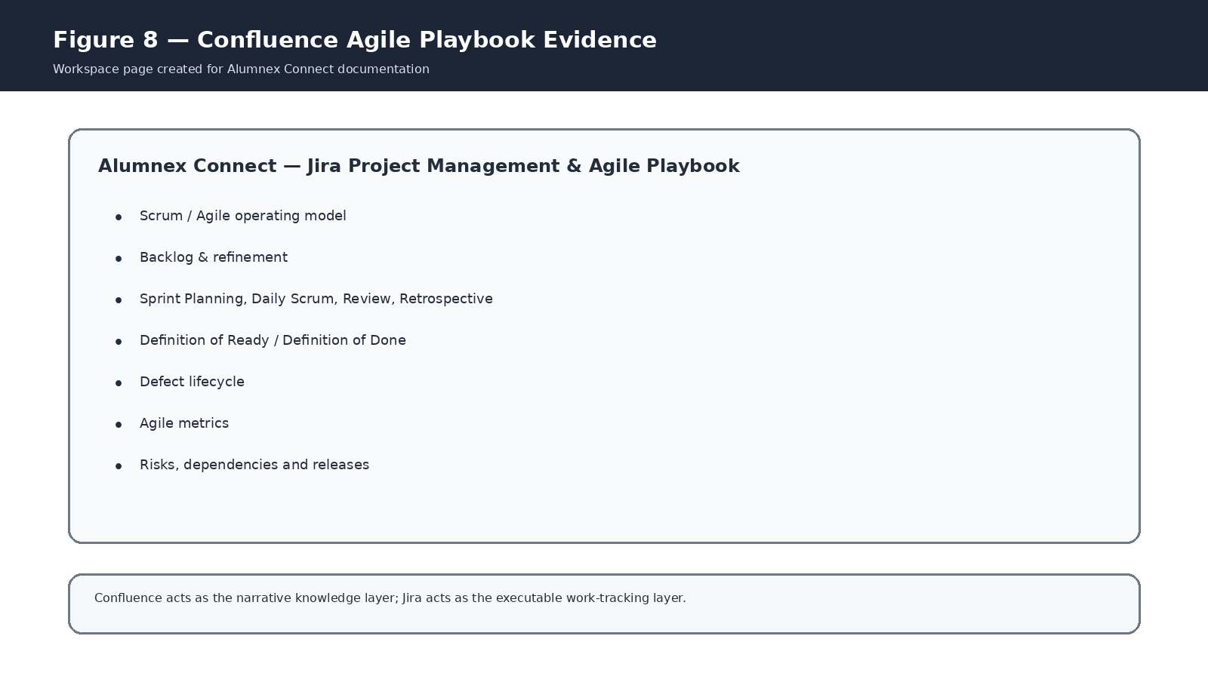
Figure 8. Confluence Agile playbook evidence visualization.
Confluence page: Alumnex Connect — Jira Project Management & Agile Playbook
Recommended relationship: Jira should answer “What work exists, what state is it in, and how is it linked?” Confluence should answer “Why are we doing it, what process do we follow, what decisions have been made, and what evidence explains the outcome?”

14. Mapping to Agile Methodologies
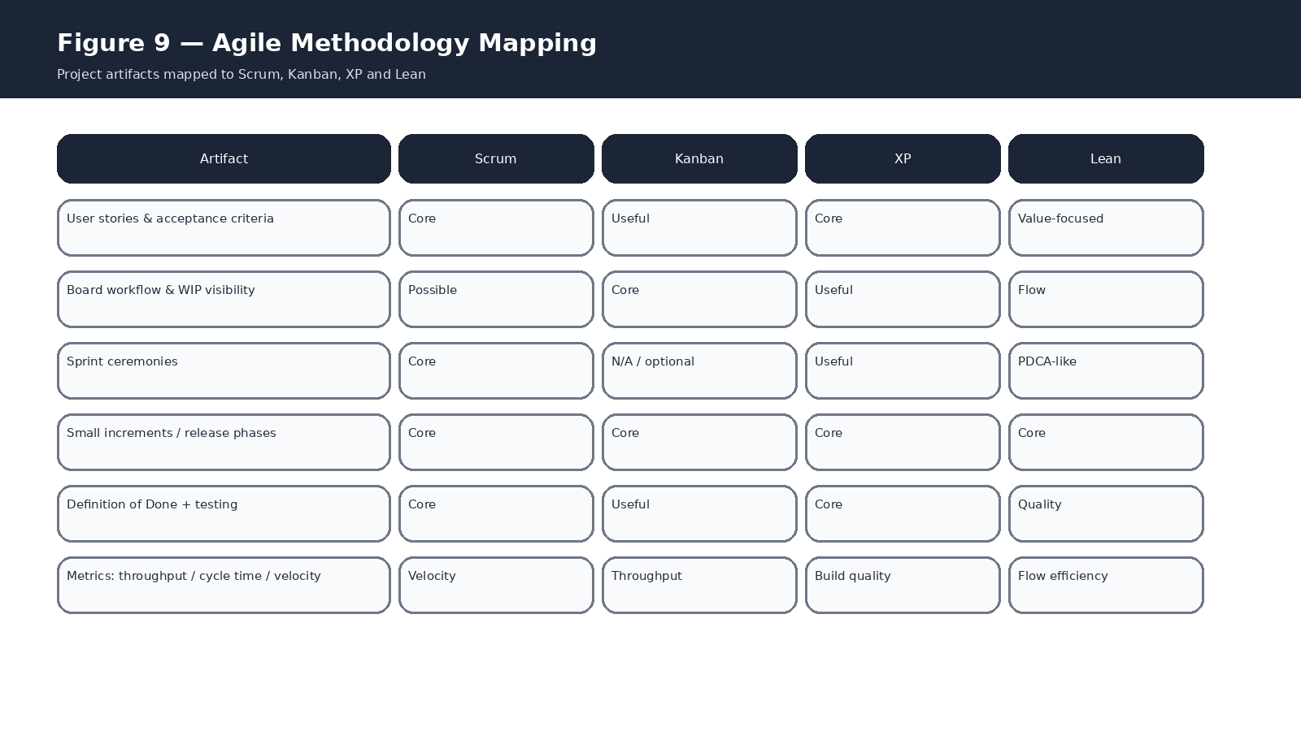
Figure 9. High-level mapping of current project artifacts to Scrum, Kanban, XP and Lean.

14.1 Scrum
Best fit for the project’s documented governance model. Product Backlog, Story decomposition, Sprint Planning, Daily Scrum, Sprint Review, Retrospective, DoR/DoD and incremental releases all map naturally to Scrum. The limitation is tooling: the current KAN board is not a native Scrum board and therefore should not be represented as if it had real Jira Sprint history.

14.2 Kanban
Strong fit with the current board because the work is visualised as a continuous flow from Idea to Done. WIP control, cycle-time monitoring, bottleneck analysis and pull-based prioritisation are the main Kanban applications. A Kanban framing is technically more accurate for the current board configuration than claiming native Scrum execution.

14.3 Extreme Programming (XP)
XP practices apply mainly at engineering level: Test-Driven Development, pair programming, refactoring, continuous integration, small releases and collective ownership. The current Jira backlog explicitly includes Automated Testing and CI/CD, so XP-aligned engineering practices can be mapped to KAN-52 and KAN-53. However, the Jira data does not prove that TDD or pair programming has been historically followed; these should be documented as intended practices unless separately evidenced.

14.4 Lean
Lean applies through elimination of waste, limiting unnecessary work, reducing handoffs, making blockers visible, shortening cycle time, and using feedback to improve the system. The lightweight release-phase structure and focus on measurable flow support a Lean interpretation. The key principle is to optimise value delivery rather than maximise task counts.

15. How Each Artifact Applies to Your Project
Artifact in Alumnex Connect | Agile purpose | Where it applies
Epic | Groups a large capability or outcome | Roadmap / product structure
Story | Expresses a user-visible outcome | Backlog / incremental delivery
Acceptance Criteria | Defines observable success | Refinement, development, testing, review
Subtask | Breaks implementation into manageable work | Development execution
Bug | Captures quality deviation | Backlog, triage, review, release readiness
Board columns | Visualises flow | Daily work management
Fix Version | Groups planned release scope | Roadmap / release planning
Blocks link | Makes sequencing risk visible | Refinement / planning
Confluence playbook | Documents process and decisions | Governance / knowledge management
DoR / DoD | Quality gates | Planning and completion
Story-point estimate | Relative size | Future Sprint planning / sizing
Metrics | Feedback on the delivery system | Review / retrospective / continuous improvement

16. Screenshot Evidence Plan
The figures embedded in this report are connector-derived evidence visualisations based on the current Jira/Confluence data. They are intentionally labelled as such so the report does not imply that a rendered PNG was captured directly from the private Jira UI. For a final academic submission, replace or supplement them with literal UI screenshots captured from your own logged-in Jira/Confluence workspace.
Screenshot | Open in workspace | What the screenshot should prove
1. Project overview | Jira → Projects → Alumnex Connect | Project name, key KAN and team-managed nature
2. Board | Jira → Project KAN → Board → KAN board | Idea/To Do/In Progress/In Review/Done columns
3. Epic + Story | Open KAN-1 and KAN-11 | Epic-to-Story hierarchy and Story fields
4. Subtask | Open KAN-26 and one child such as KAN-79 | Story-to-Subtask decomposition
5. Releases | Project settings → Versions/Releases | Five Phase versions
6. Dependency | Open KAN-33 or KAN-50 issue links section | Blocks relationships
7. Bugs | Jira search: project = KAN AND issuetype = Bug | All five defects
8. Governance | Open KAN-55 to KAN-63 | Scrum governance stories
9. Confluence playbook | Open the Agile/Scrum playbook page | Narrative process documentation
10. Story estimate | Open several Stories such as KAN-11, KAN-26, KAN-33 | Suggested estimate text in descriptions

16.1 Suggested screenshot captions for your report
- “Jira project board showing the Alumnex Connect work-item workflow from Idea to Done.”
- “Jira Epic and Story hierarchy illustrating Agile decomposition of product functionality.”
- “Jira Versions grouping the Alumnex Connect backlog into five delivery phases.”
- “Jira issue links showing dependencies and potential blockers between work items.”
- “Jira bug register representing observed defects as visible Agile work.”
- “Confluence Agile/Scrum playbook documenting the project’s governance and quality model.”

17. Important Constraints and Academic Reporting Rules
- Do not write that the project has completed historical Scrum Sprints unless you have independent evidence of Sprint records.
- Do not describe the current KAN board as a Jira Scrum board; the verified board type is simple/team-managed.
- Do not claim native Story Points are populated; the project metadata currently exposes no Story Points field.
- Treat the five Bugs as observed/reported defects and verify them against the current implementation before closure.
- When describing dependencies, distinguish a strict “Blocks” relationship from a looser “Related” relationship during future backlog refinement.
- Use Agile metrics to improve planning and flow; do not frame them as individual performance scores.

18. Recommended Operating Model for Future Iterations
A strong future-state operating model is a two-layer approach: use Jira for executable work tracking and use Confluence for the narrative system of record. Within Jira, maintain clear Stories, acceptance criteria, subtasks, Bugs, Versions and links. During refinement, ensure every proposed Sprint item is Ready. During execution, use the board to show work in progress and blockers. During Review, demonstrate the increment. During Retrospective, convert improvement ideas into traceable Jira actions.
When a real Scrum board becomes necessary, the project should be migrated/recreated as a company-managed Scrum project rather than silently treating the current team-managed board as if it were one. That change should be planned because it affects project configuration and issue history.

19. Appendix A — Complete Epic Register

KAN-1 — Authentication & User Management
Identity, authentication, profiles and access control

KAN-2 — Alumni–Student Mentorship
Mentorship discovery, requests, sessions and reviews

KAN-3 — Developer Intelligence — DevPulse
Coding activity integrations and developer consistency

KAN-4 — Career & Job Management
Jobs, applications and ATS resume analysis

KAN-5 — AI Career Assistant
AI mentor, skill gaps, mock interview and provider failover

KAN-6 — Real-Time Communication
Chat, groups, presence, receipts and notifications

KAN-7 — Community & Events
Forum, events and alumni networking

KAN-8 — Mobile Application
Android wrapper, auth, responsiveness, notifications and release

KAN-9 — Security, Reliability & DevOps
Security hardening, failover, testing, CI/CD and monitoring

KAN-10 — Scrum & Project Governance
Backlog, ceremonies, quality gates, risks, releases and metrics

20. Appendix B — Story Register
The points below are the “Suggested estimate” values found in the current Jira Story descriptions; they are not native Story Points fields.
Key | Story | Suggested points
KAN-11 | Student Registration | 5
KAN-12 | Student Login | 5
KAN-13 | OAuth Authentication | 5
KAN-14 | OTP / Two-Factor Authentication | 5
KAN-15 | User Profile Management | 3
KAN-16 | Role-Based Access Control | 5
KAN-17 | Browse Alumni Mentors | 5
KAN-18 | Request Mentorship | 5
KAN-19 | Manage Mentorship Requests | 5
KAN-20 | Mentorship Session Tracking | 5
KAN-21 | Mentorship Reviews | 3
KAN-22 | GitHub Developer Statistics | 5
KAN-23 | LeetCode Statistics | 5
KAN-24 | Codeforces Statistics | 5
KAN-25 | Unified Developer Profile | 3
KAN-26 | Activity Hub | 8
KAN-27 | Streak Tracking | 5
KAN-28 | Job Posting | 5

Key | Story | Suggested points
KAN-29 | Browse Job Opportunities | 5
KAN-30 | Apply for Jobs | 5
KAN-31 | Job Application Management | 5
KAN-32 | ATS Resume Analysis | 8
KAN-33 | AI Career Mentor | 8
KAN-34 | Skill Gap Analysis | 8
KAN-35 | AI Mock Interview | 8
KAN-36 | AI Provider Failover | 5
KAN-37 | Real-Time Chat | 8
KAN-38 | Chat Groups | 5
KAN-39 | Online Presence | 3
KAN-40 | Read Receipts | 3
KAN-41 | Real-Time Notifications | 5
KAN-42 | Community Forum | 5
KAN-43 | Event Management | 5
KAN-44 | Alumni Networking | 5
KAN-45 | Android Mobile Wrapper | 8
KAN-46 | Mobile Authentication | 5

Key | Story | Suggested points
KAN-47 | Mobile Responsive UI | 5
KAN-48 | Mobile Notifications | 5
KAN-49 | Android APK Build & Release | 3
KAN-50 | Security Hardening | 8
KAN-51 | API Failover | 5
KAN-52 | Automated Testing | 5
KAN-53 | CI/CD Pipeline | 5
KAN-54 | Production Monitoring | 3
KAN-55 | Product Backlog & Refinement | 3
KAN-56 | Sprint Planning | 3
KAN-57 | Daily Scrum Tracking | 2
KAN-58 | Sprint Review & Stakeholder Feedback | 3
KAN-59 | Sprint Retrospective & Improvement Actions | 3
KAN-60 | Definition of Ready & Definition of Done | 3
KAN-61 | Risk, Dependency & Decision Tracking | 3
KAN-62 | Release & Version Tracking | 3
KAN-63 | Agile Metrics & Continuous Improvement | 3

21. Appendix C — Subtask Register
Key | Subtask
KAN-69 | Design registration flow
KAN-70 | Implement secure credential handling
KAN-71 | Registration tests
KAN-72 | Implement login flow
KAN-73 | Handle authentication failures
KAN-74 | Login tests
KAN-75 | Mentor search and filters
KAN-76 | Mentorship request workflow
KAN-77 | Mentorship request tests
KAN-78 | GitHub integration
KAN-79 | Activity aggregation
KAN-80 | Streak calculation
KAN-81 | Resume PDF extraction
KAN-82 | ATS scoring
KAN-83 | AI chat integration
KAN-84 | Socket messaging
KAN-85 | Notification deduplication
KAN-86 | Android wrapper
KAN-87 | FCM registration
KAN-88 | Security review

22. Appendix D — Bug Register
Key | Bug | Primary Agile response
KAN-64 | Daily Goal / Streak Synchronization Loss | Investigate sync reliability; add idempotency and last-sync visibility
KAN-65 | Duplicate Reminder Notifications | Deduplicate delivery events across channels
KAN-66 | FCM Push Notification Delivery Failure | Validate token lifecycle, credentials and retry handling
KAN-67 | Google OAuth Redirect URI Mismatch | Align OAuth configuration with deployed callbacks
KAN-68 | Google Calendar Scope Access Denied | Minimise scopes and handle consent/denial correctly
End of documentation. For a final report, pair this document with literal Jira/Confluence screenshots captured from the live workspace using Section 16 as the evidence checklist.

